**ECO3702: Advanced Macroeconomics Lecture Note 3:**

2018

Introduction to Mundell– Fleming Model

**Kaan Öğüt**

Bahçeşehir unıversıty

**O**

**pen Economy Mundell – Fleming Model:**

Mundell-Fleming model is simply the IS-LM model adapted to the open economy. To extend the traditional IS-LM model to the open economy, Robert Mundell and Marcus Fleming added one further element to the analysis, the **balance of payments equilibrium,.** The closed economy IS-LM model thus turned into the open economy Mundell-Fleming model, allowing for an effective discussion of the effects of various economic policies in the open economy (Eicher, Mutti, Turnovsky, 2009, 525).



We will use the Mundell-Fleming framework to analyze the effects of monetary policy, fiscal policy, or exchange rate policy on the economy. The outcomes will be shown to depend on

1. Exchange rate regime (fixed or flexible), and

*ii*) Degree of capital mobility (low, high, or perfect).

The three markets considered in the MF model are:

a) the goods market illustrated by the **IS** curve,

b) the financial (money-bonds) markets summarized by the **LM** curve, and

c) the newly introduced notion of **external balance** or ***BP*=0** represented by the **BP** curve.

 

*We make some additional assumptions that will be relaxed later on, we assume a short-run model where prices are fixed.*

The difference between exports and imports of goods and services is known as the net export or current account. 

**Nominal and Real Interest Rates:**

As you remember it is supposed that **Investment** and **consumption** depend on the **real interest** rate but **money demand** and **capital flow** - depend on the **nominal interest rate** (Mankiw, 2000, 300; Blanchard, 2011, 297).



Nominal interest rate is the interest rate that bonds earn or interest rate that banks offer for deposits (*it can be taken by depositors at the end of the period*) or charges for loans (*it have to be paid by loan debtor at the end of the period)*.



The real interest rate is the amount of extra purchasing power a lender must be paid for the rental of his or her money. (*Lenders always lend funds above the expected inflation rate; otherwise, they would lose wealth*). Hence the real interest rate is the interest rate that is adjusted by subtracting expected changes in the price level (inflation) to accurately reflect the real cost of borrowing. According to Fisher the nominal interest rate equals the real interest rate plus the expected rate of inflation. (Mishkin, 2012, 39)



For now according to fixed price Mundell Fleming Model nominal interest rate equals real interest rate.

If the price is fixed expected inflation rate should be zero.



**Nominal and Real Exchange Rates:**



Nominal Exchange Rate: is the price of the foreign currency in terms of the domestic currency.



An **appreciation of the domestic currency** is a decrease in the price of the foreign currency in terms of a domestic currency and corresponds to a decrease in the exchange rate.

A **depreciation of the domestic currency** is an increase in the price of the foreign currency in terms of a domestic currency and corresponds to an increase in the exchange rate.

There are two more words to denote movements in exchange rates. Revaluations and devaluations. These two terms are used when countries operate under fixed exchange rates

Real Exchange Rate:



If the prices are fixed then the nominal and real exchange rates move together. We can use either of them in our model.

**Example:** Suppose that there is no change in nominal exchange rate but countries inflation rates are different. How would change the real exchange rate.

$$1\$=3 ₺ \overset{→}{π=20\% { π}^{*}=4\%} 1\$=3 ₺$$

$$ε_{0}=\frac{3*100}{100}=3\overset{→}{π=20\% { π}^{*}=4\%} ε_{1}=\frac{3*104}{120}=2,6$$

If you want to keep the real exchange rate fixed at its initial, what would the nominal exchange rate be.

$${1\$=3 ₺ and ε}_{0}=\frac{3*100}{100}=3\overset{→}{π=20\% { π}^{*}=4\%} ε_{1}=\frac{E_{1}*104}{120}≅3$$

$$E_{1}=\frac{3*120}{104}=3,46 ₺$$

**Expenditure Components of GDP**

The national accounts are used to measure the output of an economy. The most commonly used measure for calculating national output is gross domestic product. GDP can be measured in three different ways. (Carlin, Soskice, 2015, 4)

1. **Value Added or Production Method**. This method measures GDP as the value added created in all sectors of the economy.
$$Y=value of output sold-cost of raw materials and intermediate goods$$

2. **Expenditure Method**:
3. **Income Method**: This method measures GDP as the total income of all agents in the economy such that.

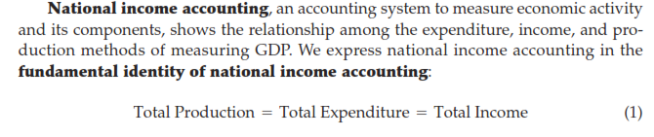





**Expenditure Method:**

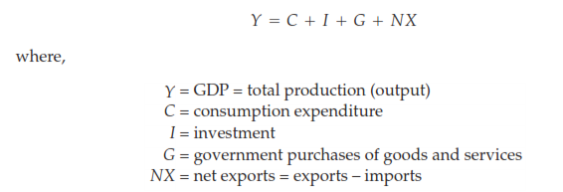

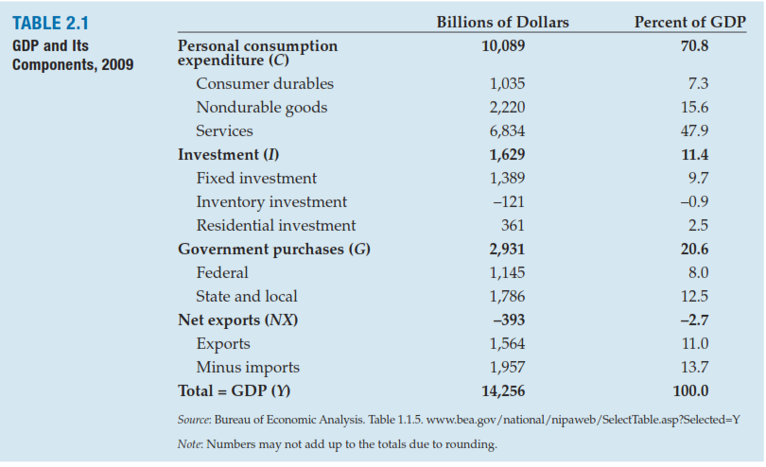

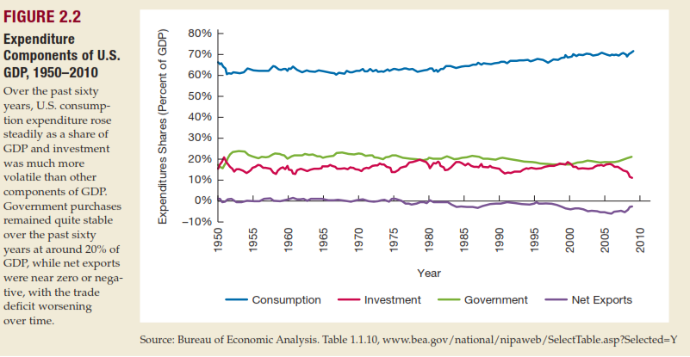

It has been seen that investment is much more volatile than consumption and government spending. Investment decision depends on expected profits and is very dependent on how optimistic firms are. Investment can also be postponed in recession, whereas government spending and consumption cannot be easily delayed(Carlin, Soskice, 2015, 5)

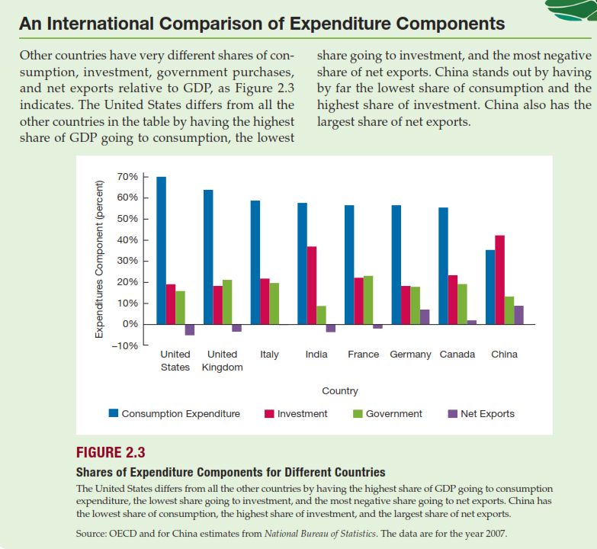

**Goods Market in an Open Economy:**



If the imports are measured in terms of foreign currency they would have been multiplied with the real exchange rate to convert them in terms of domestic currency.



Real consumption spending by households $C$ is positively related to real disposable (after tax) income [1]







: Domestic demand for domestic goods



: Imports (Domestic demand for foreign goods)



*EX*: Exports (Foreign demand for domestic goods)











**Determinants of Imports and Exports**

Imports are the part of the **domestic demand for foreign goods**. They depend on domestic income. Higher income leads to a higher domestic demand also imports.



Imports also depend on the real exchange rate. The more expensive domestic goods are relative to foreign goods the higher the domestic demand for foreign goods. Thus lower exchange rate **appreciation of domestic currency** leads to higher imports. Appreciating domestic currency makes foreign goods cheaper, (makes import more attractive) and leads to an increase in import.

An increase in foreign income, Y*, leads to an increase in exports. **Also an increase in real exchange rate** (that indicates **depreciation of domestic currency**) **makes foreign goods more expensive relative to domestic goods**. **Cheaper domestic goods support the exports.** An increase in the real exchange rate, leads to an increase in exports.



 

**How Real Exchange Rate Changes Affect the Current Account**

To determine how such a change in the relative price of national outputs affects the current

account, other things equal, we must ask how it affects both *EX* and *IM*.

**When real exchange rate**  **rises,** for example, **foreign products have become more expensive relative to domestic products:**

**Each unit of domestic output now purchases fewer units of foreign output**. Foreign consumers will respond to this price shift by demanding more of our exports. This response by foreigners will therefore raise ***EX*** and will tend to improve the domestic country’s current account.

**The effect of the same real exchange rate**  **increase on *IM* is more complicated**. **Domestic consumers respond to the price shift by purchasing fewer units of the more expensive foreign products.** **Their response does not imply, however, that value of *IM* must fall, because *it* denotes the *value* of imports measured in terms of domestic output, not the *volume* of foreign products imported**. Since **a rise in  tends to raise the value of each unit of imports in terms of domestic output units, imports measured in domestic output units may rise as a result of a rise in  even if imports decline when measured in foreign output units**. ***IM* can therefore rise or fall when**  **rises, so the effect of a real exchange rate change on the current account *CA* is ambiguous**.

Whether the current account **improves** or **worsens** depends on which effect of a real exchange rate change is dominant—**the *volume effect***of consumer spending shifts on export and import quantities, or the ***value effect***, which changes the domestic output equivalent of a *given* volume of foreign imports. We assume for now that the volume effect of a real exchange rate change always outweighs the value effect, so that, other things equal, **a real depreciation of the currency improves the current account and a real appreciation of the currency worsens the current account.**

**Depreciaion and the trade Balance: The Marshall-Lerner Condition:**



According to definition of net exports, real exchange rate enters the right side of the equation in three places this makes it clear that the **real depreciation affects the trade balance through three separate channels:**

* **Exports increase.** The real depreciation makes **domestic goods relatively** less expensive (**cheaper**) abroad. This leads to an increase in foreign demand for domestic goods so an increase in Turkey exports.
* **Imports decrease**. The real depreciation makes **foreign goods relatively more expensive** in Turkey. This leads to shift in domestic demand from foreign goods to domestic goods so leads to a decrease in the quantity of imports.
* **The relative price of foreign goods in terms of domestic goods increases**. This **increases the import bill**, . The same quantity of imports now cost more to buy (in terms of domestic goods)



It is important to know whether depreciation of the domestic currency improves the trade balance or not. **Depreciation of domestic currency will increase exports and reduce imports, but it will increase the cost of imports.** Hence, the outcome depends on how sensitive are exports and imports to changes in the real exchange rate.

For the trade balance to improve following depreciation, exports must increase enough and imports must decrease enough **to compensate for the increase in the price of imports.** The condition under which a real depreciation leads to an increase in net exports is known as the Marshall – Lerner condition.

Elasticity of imports and exports with respect to real exchange rate are described respectively.

$$NX=X-ℇ*IM$$

$$∆NX=∆X-∆\left(ℇ*IM\right)$$

$$∆NX=∆X-∆ℇ*IM-ℇ*∆IM$$

$$\frac{∆NX}{∆ℇ}=\frac{∆X}{∆ℇ}-\frac{∆ℇ*IM}{∆ℇ}-\frac{ℇ*∆IM}{∆ℇ}$$

$$\frac{∆NX}{∆ℇ}=\frac{∆X}{∆ℇ}-\frac{∆ℇ*IM}{∆ℇ}-\frac{ℇ*∆IM}{∆ℇ}$$

If trade is initially balanced











**The current account could immediately decrease after a currency depreciation, then increase gradually as the volume effect begins to dominate the value effect.**





**Investment - Saving Equilibrium**

Providing of equilibrium condition of the commodity market in next equation implies the **saving investment balance**.

$$Y=C+I+G+NX$$

$S$ indicates national savings

$$S=\underset{S^{P}}{\underbrace{Y-T-C}}+\underset{S^{G}}{\underbrace{T-G}}$$

$$S=Y-C-G$$

Consideration of equations requires saving investment balance.

$$S=I+NX$$

**Money Market in an Open Economy**

$$M^{S}=\frac{1+c}{rr+e\left(i^{ER}\right)+c}\left[L^{CB}\underset{-}{\underbrace{\left(i^{P}\right)}}+B^{CB}+E*IR\right]$$

**Foreign Exchange Market:** The international sector is characterized by the balance of payments, *BP*, equal to the sum of the **current account** (net export) and the **financial account** (capital inflow)

$$BP=CA+FA=0$$

$$BP=\underset{Current Account }{\underbrace{X\left(\frac{EP^{f}}{P}\right)-IM\left(\frac{EP^{f}}{P}\right)}}+\underset{Financial Account}{\underbrace{K\left(i-i^{f}\right)}}$$

|  |  |  |  |  |  |  |  |  |  |
| --- | --- | --- | --- | --- | --- | --- | --- | --- | --- |
| **Current Account Surplus, Top 10 Economies,** Billions of US dollars | | | | | | | | | |
|  | 2010 | 2011 | 2012 | 2013 | 2014 | 2015 | 2016 |  |  |
| China, P.R.: Mainland | 237,8 | 136,1 | 215,4 | 148,2 | 236,0 | 304,2 | 196,4 |  |  |
| Germany | 193,0 | 228,7 | 248,9 | 252,4 | 288,2 | 288,2 | 286,8 |  |  |
| Japan | 220,9 | 129,6 | 60,1 | 46,4 | 36,4 | 134,1 | 187,3 |  |  |
| Korea, Republic of | 28,9 | 18,7 | 50,8 | 81,1 | 84,4 | 105,9 | 99,2 |  |  |
| Switzerland | 86,7 | 55,2 | 68,7 | 77,8 | 60,0 | 73,8 | 63,2 |  |  |
| Russian Federation | 67,5 | 97,3 | 71,3 | 33,4 | 57,5 | 68,8 | 25,5 |  |  |
| Netherlands | 61,8 | 81,3 | 89,5 | 85,5 | 75,9 | 65,8 | 65,6 |  |  |
| Singapore | 55,4 | 61,0 | 50,3 | 51,2 | 60,8 | 53,8 | 56,5 |  |  |
| Thailand | 11,5 | 9,4 | -1,7 | -4,9 | 15,2 | 32,1 | 48,2 |  |  |
| Ireland | 2,3 | 2,8 | 9,2 | 14,4 | 8,9 | 31,7 | 14,3 |  |  |

|  |  |  |  |  |  |  |  |  |  |
| --- | --- | --- | --- | --- | --- | --- | --- | --- | --- |
| Current Account Deficit, Top 10 Economies,  Billions of US dollars | | | | | | | | | |
|  | 2011 | 2012 | 2013 | 2014 | 2015 | 2016 | 2017 |  |  |
| United States | -444,6 | -426,2 | -349,5 | -373,8 | -434,6 | -451,7 |  |  |  |
| United Kingdom | -62,2 | -113,1 | -151,9 | -161,2 | -149,8 | -154,9 |  |  |  |
| Brazil | -77,0 | -74,1 | -74,8 | -104,2 | -59,4 | -23,5 | -9,8 |  |  |
| Australia | -44,4 | -64,5 | -47,9 | -42,3 | -58,1 | -32,9 |  |  |  |
| Saudi Arabia | 158,5 | 164,8 | 135,4 | 73,8 | -56,7 | -23,8 |  |  |  |
| Canada | -49,7 | -65,7 | -59,4 | -43,2 | -56,2 | -49,4 |  |  |  |
| Turkey | -74,4 | -48,0 | -63,6 | -43,6 | -32,1 | -33,1 | -47,1 |  |  |
| Mexico | -13,0 | -16,8 | -30,7 | -23,8 | -29,5 | -22,7 |  |  |  |
| Algeria | 17,7 | 12,1 | 1,2 | -9,5 | -27,2 | -26,2 |  |  |  |
| India | -62,5 | -91,5 | -49,1 | -27,3 | -22,5 | -12,1 |  |  |  |

[Theoretically, the BOP should be zero](http://www.investopedia.com/articles/03/060403.asp#axzz1rYFTbCfM). Thus, the current account on one side and the capital and financial account on the other should balance each other out.

This zero balance is achieved (maintained) through movement of the exchange rate under the flexible exchange rate regime.

If it is not exactly satisfied central bank will intervene in the foreign exchange market. Otherwise exchange rate would be more fluctuating.

$$BP=\underset{Current Account }{\underbrace{X\left(\frac{EP^{f}}{P}\right)-IM\left(\frac{EP^{f}}{P}\right)}}+\underset{Financial Account}{\underbrace{K\left(i-i^{f}\right)}}-\underset{change in international reserves of CB}{\underbrace{∆IR}}$$

# Net errors and omissions:

Net errors and omissions constitute a residual category **needed to ensure that accounts in the balance of payments statement sum to zero.** Net errors and omissions are derived as the balance on the financial account minus the balances on the current and capital accounts. Net errors and omissions record the statistical discrepancies that arise in gathering balance of payments data. Also in some situations it can be taken as **capital inflow of unknown origin**.

**China** has recorded **both current account and financial account surpluses**, which requires the expansion of reserve asset holding as a balancing item (note that all items must add up to zero, so positive numbers from both current and capital accounts must be balanced by a negative number of equal magnitude in the reserve account, and negative number in reserve asset account means an increase of reserve asset).

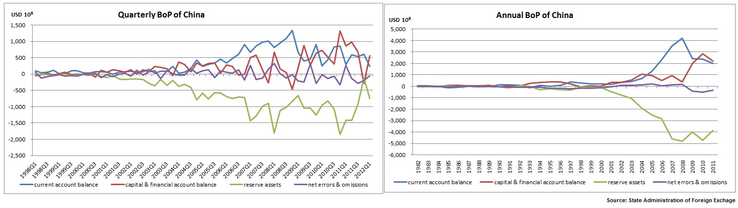

Change in international reserves should be included by the balance of payments account.

**China’s Foreign Exchange Reserves**

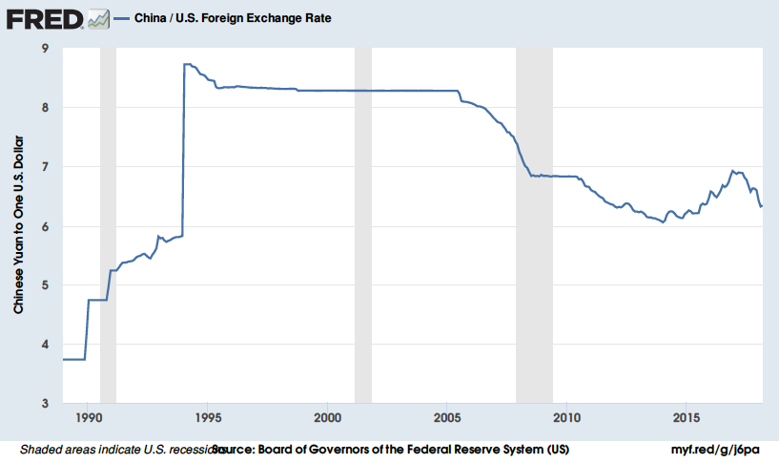

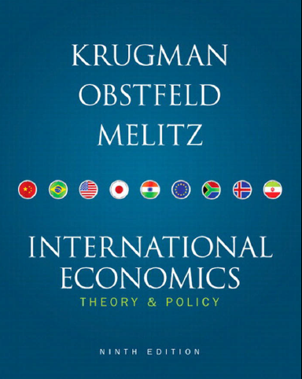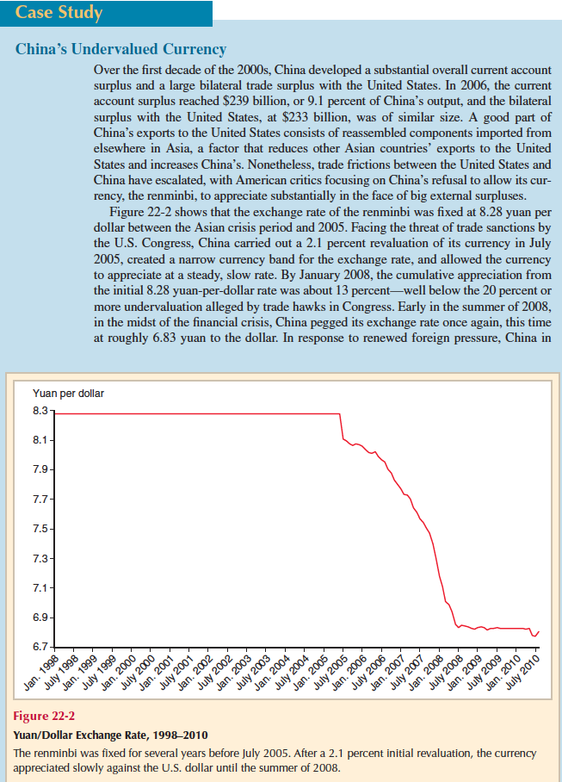

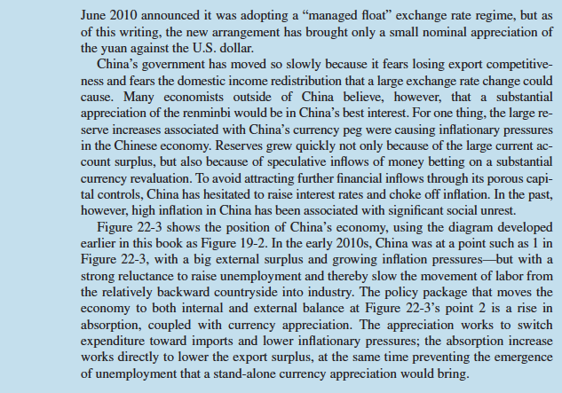

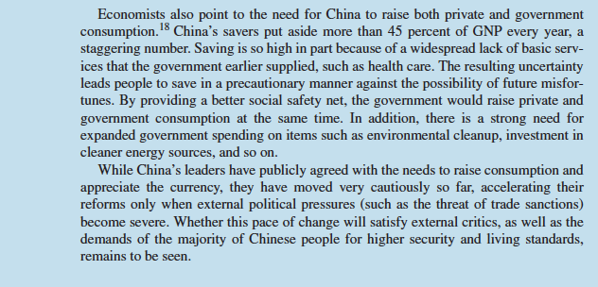

$$BP=\underset{Current Account }{\underbrace{X\left(\frac{EP^{f}}{P}\right)-IM\left(\frac{EP^{f}}{P}\right)}}+\underset{Financial Account}{\underbrace{K\left(i-i^{f}\right)}}-\underset{change in international reserves of CB}{\underbrace{∆IR}}$$

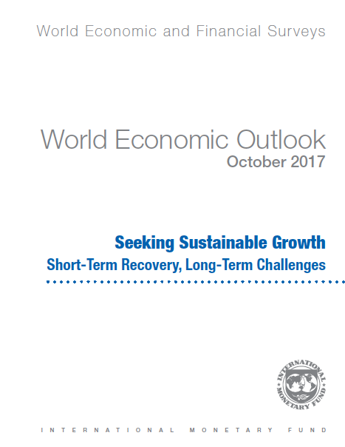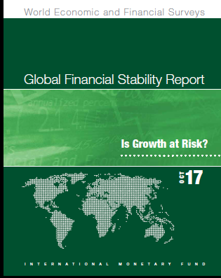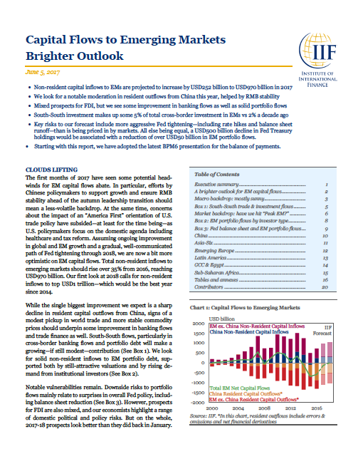

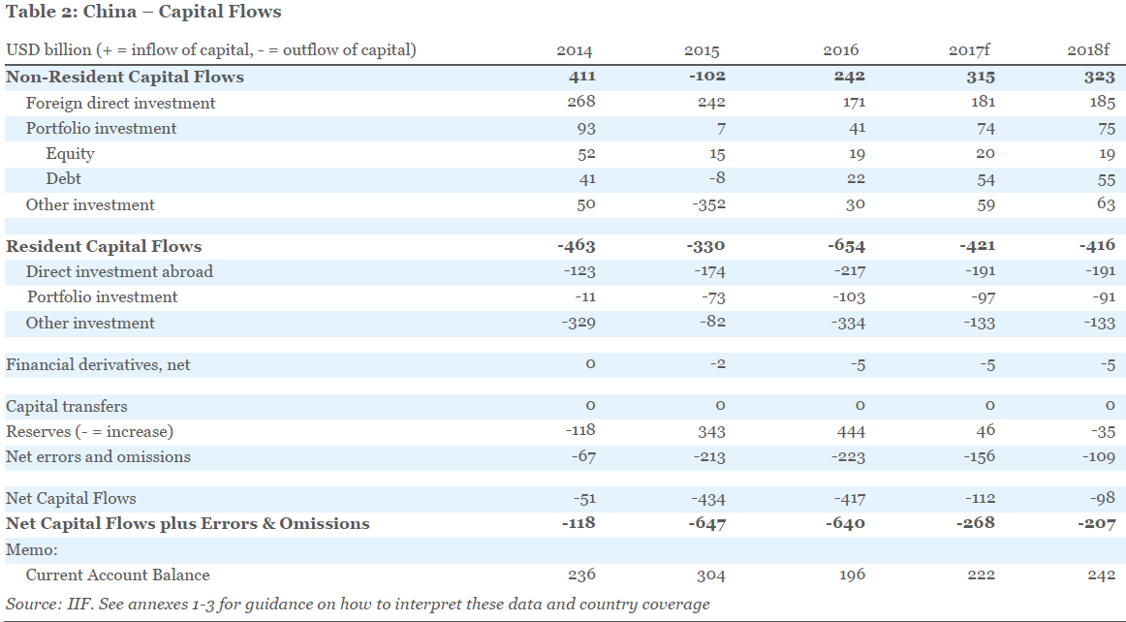

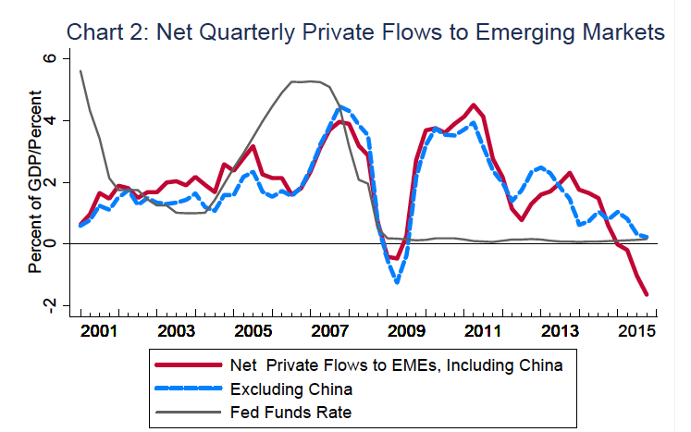

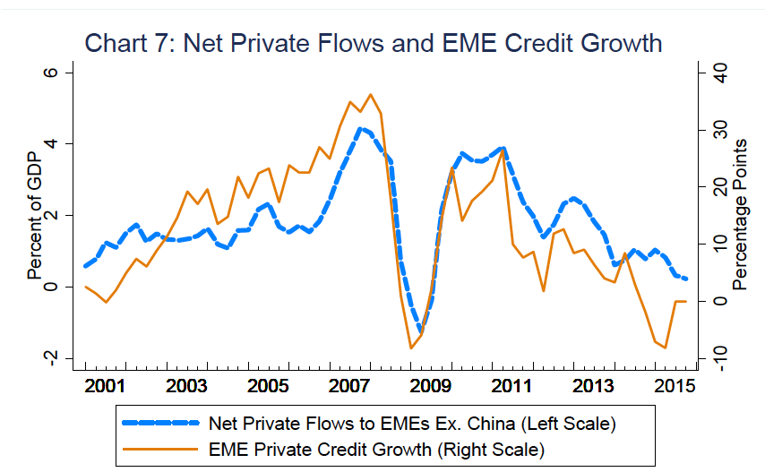

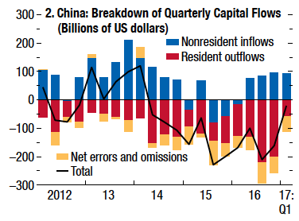

Capital flows to emerging market economies have remained resilient in recent months, continuing their recovery after a sharp decline in late 2015 and early 2016.

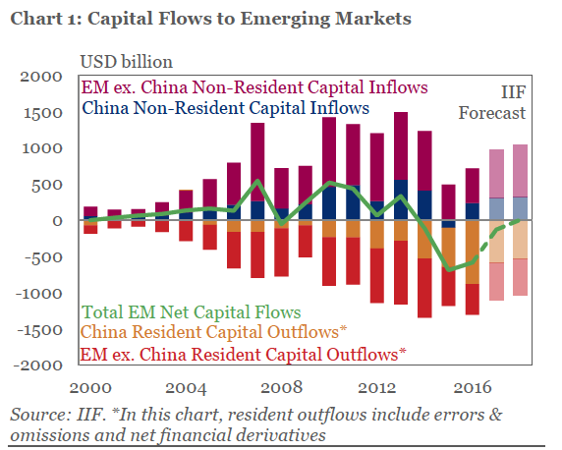

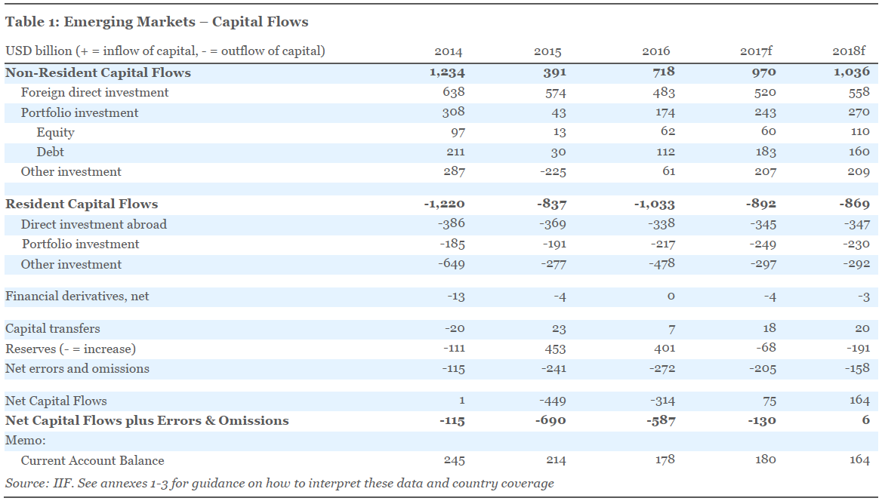

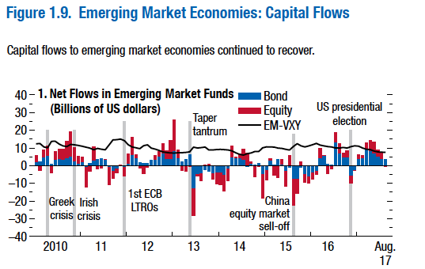

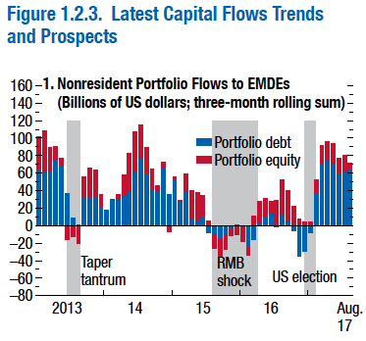

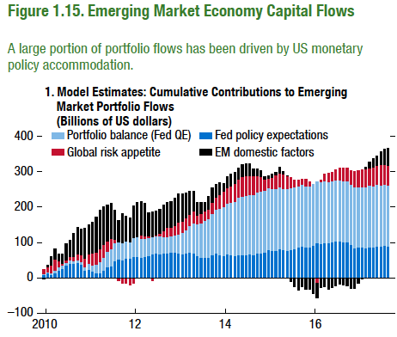

[Theoretically, the BOP should be zero](http://www.investopedia.com/articles/03/060403.asp#axzz1rYFTbCfM). Thus, the current account on one side and the capital and financial account on the other should balance each other out.

**This zero balance is achieved** (maintained) **through movement of the exchange rate under the flexible exchange rate regime**. If it is not exactly satisfied, central bank will intervene in the foreign exchange market. Otherwise exchange rate would be more fluctuating.

**Capital Flow and Uncovered Interest Rate Parity:**

Include the Expected Exchange Rate of Depreciation in the Capital Flow Function

$$K\left(i-i^{f}\right)=K\left(i-i^{f}-{\dot{e}}^{e}\right)$$

$${\dot{e}}^{e}=\frac{E_{t+1}^{e}-E_{t}}{E_{t}}$$

Assume that there are two kinds of assets as **domestic and foreign one year bonds** and suppose any foreign investor decides to hold Turkish one year bonds.

To buy Turkish bonds he (she) must first buy Turkish Lira. Let be the nominal exchange rate at the start of year For every he (she) get .



Let denote the one year nominal interest rate on Turkish bonds in year . When next year comes, he (she) will have



He (she) will then have to convert his (her) liras back into dollars. If he (she) expect the nominal exchange rate next year to be **each lira will be worth dollar**. So he (she) can expect to have next year for every $*1* he (she) invest now.



In assessing the attractiveness of Turkish bonds versus US bonds.

Expected depreciation of exchange rate also should have been considered together with difference in interest rates. You must assess what you think will happen to the exchange rate between this year and next.



**When the expected return of domestic bonds equal as foreign bonds, investor will be indifferent between them** so this statement gives us interest rate parity condition.



After some arrangements it will become



This equation ignores transaction costs and risk that can be originated by special conditions of a country.



**Derivation of Uncovered Interest Rate Parity:**



relatively small so it can be ignored.



financial investors wants to invest their wealth in TL



They borrow TL and invest in dollars.



**Slopes of IS – LM – BP Curves**



According to following assumtions.



**We can use implicit function derivative rule.**

**Derivative of Implicit Functions:**





**The Basic IS-LM-BP Model in Equilibrium**

**The Mundell-Fleming Model**



**At point a, the goods markets (IS), the financial markets (LM), and the foreign exchange market (BP) are all in equilibrium.**

1. It could be negatively related with real interest rates $r$. When the real interest rate is higher, the real return to saving is also higher, and so you will spend less and save more.